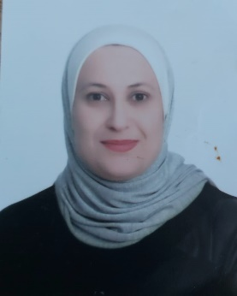
Dr.Manal Fathi Anabtawi

Associate Professor in Disaster & Crises Management
Department of Social Work/ University of Jordan

Work telephone number: +962 6 5355000/ Ext: 24989
P.O. Box 1349 Amman, 11941Jordan
Mobile (whatsapp) +962 795393331

Dr.manal.anabtawi@gmail.com / M.anabtawi@ju.edu.jo

PERSONAL INFORMATION

Nationality : Jordanian
Gender : Female
Date & Place of Birth : September 24th, 1979, Irbid-Jordan
Marital Status : Married

EDUCATION
- B.A degree in Sociology with an average of (3.77 out of 4) rating Distinguished. University of Jordan 19972001.

- M.A degree in Sociology with an average of (3.94 out of 4) rating Distinguished. University of Jordan 2001-2004.

- PhD degree in Social Work/ Disaster and Crises Management. University of Kent at Canterbury, England. United Kingdom 2008-2012. Thesis (Crisis Management in Jordan: Case Study of the Iraqi Crisis).

WORK EXPERIENCES

- 2001-2003: Social researcher, Department of Planning and Monitoring. Ministry of Social Development.
- 2007-2008: Teacher assistant, Department of Sociology and Social work, University of Jordan.
- 2013-2020: Assistant Professor, Department of Social Work, University of Jordan.
- 2020-until now: Associate Professor, Department of Social Work, University of Jordan
- August/2021: Head of Department, Social Work, University of Jordan

SKILLs
- Demonstrated leadership ability and strong team player
      - Ability to manage multiple priorities
      - Ability to work well under pressure
      - Excellent analytical skills
      - Excellent presentation skills and seminar discussions
      - Excellent computer skills in MS Word, Power point and internet usage
      - Excellent communication skills

LANGUAGES
- Arabic : Mother Language
      - English : Fluent (Writing, Speaking and Listening)

Other Experiences

- Reviewer in Qatar National Research Fund.
- Focal point between University of Jordan and National Center for Security and Crises Management.
- Founding member in the Association of Jordanian Women Academic (AJWA)/ 2014
- Member in the Association of Social Work/ 2014
- Reviewer in Journal of International Social Work, United Kingdom.
- Reviewer in Journal of International Sociology.
- Reviewer in Journal of Dirasat, University of Jordan.
- Participant in workshop: Syrian Refugees and Migrants Issues. Conducted by UNHCR and Ministry of Interior, Aqaba/ Jordan 2013.
- Participant in workshop: Violence within Students Universities. Conducted by Berkuf Association/ Germany, in Amman 2015.
- Attend several conferences.

REFERENCES
Available upon Request

